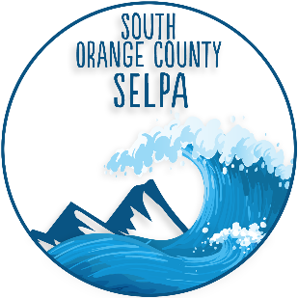

SELPA Priorities
2021-2022

The Local Plan calls for the SELPA to have priorities for each year:

- Program support to LBUSD and SVUSD
- Program support for County and other out of SELPA placements
- Local Plan adherence
- Compliance with Federal and State requirements
- Reporting data to California Department of Education
- Staff development for both LBUSD and SVUSD
- Liaison with State and County agencies
- CAC Leadership and community support

