Class of 2018 GRADUATION BANNERS!

Congratulations! You put in four years of hard work and now have big dreams for your future!

We want to honor your post-high school plans by offering customized graduation banners to be on display around the track during the graduation ceremony. After the graduation ceremony, they are yours to keep and hang in your room or dorm!

$50—orders must be submitted to Mrs. McAlister in room 504 or to her mailbox by May 21

*All proceeds benefit the MVHS AVID Program

*IT IS THE RESPONSIBILITY OF THE FAMILIES TO PICK UP BANNERS AT THE TABLE ON THE TRACK IMMEDIATELY FOLLOWING THE GRADUATION CEREMONY.

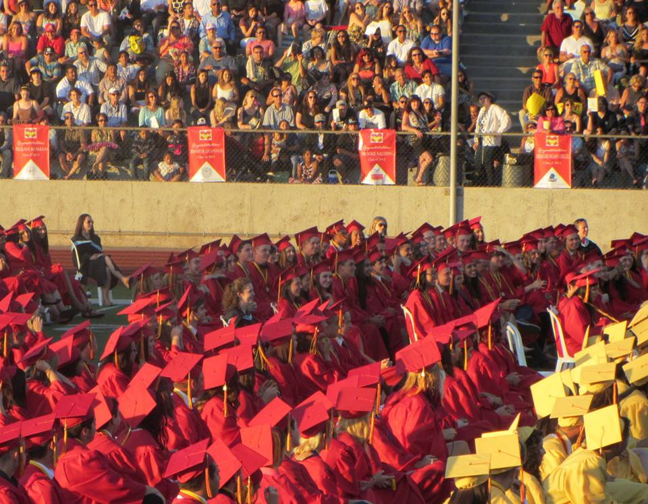
Banners are 3’ x 2’ and are customized for the student and individual college or post secondary institution.

To ask questions or to turn in your order form, contact Mrs. McAlister in room 504 or e-mail her directly at mcalisterk@svusd.org

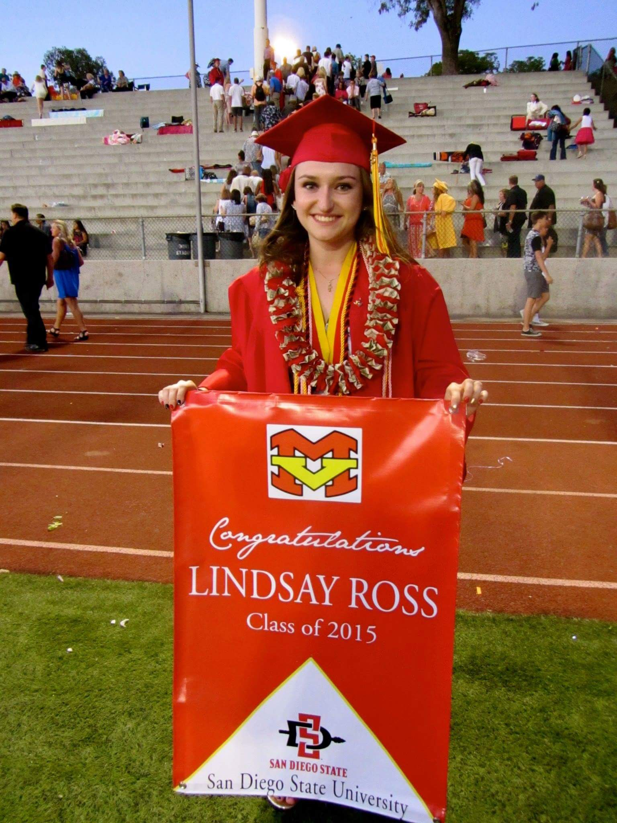

Class of 2018
GRADUATION BANNER
ORDER FORM

Banners are 3’x 2’ and are customized for the student and individual college or post-secondary institution.

$50—MAY 21 deadline
*Please make checks payable to MVHS AVID.

All proceeds benefit Mission Viejo High School’s AVID program that strives to prepare students for college readiness and success in a global society.

Turn in to Mrs. McAlister’s box or to room 504 by May 21. Orders after the deadline will not be accepted.

Student’s name (as you would like it to appear on banner). Names will be printed in all capital letters:

Mailing address:

Phone: e-mail:
College of acceptance (as you would like it to appear on banner). The way you write it below is exactly how it will appear. Consider your preference of using the college initials or spelling out the entire college name. (UCLA vs. University of California, Los Angeles)
College city/state:
Please send your university seal or logo electronically to Mrs. McAlister at mcalisterk@svusd.org to customize your banner. If you do not provide the image, the university seal will be selected for you.

Do you want the default seal selected for you?
_______Yes
_______No, I’m sending the one I want.
If plans include the military, write the name of the name of the branch of the military as you would like it to appear on the banner.

Do you want the default seal selected for you?
_______Yes
_______No, I’m sending the one I want.

